MARCH 2023 NEWSLETTER
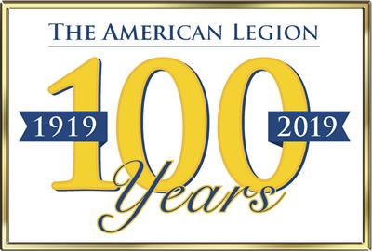
PLEASE TAKE NOTE:
“MARCH MEETING-MARCH 18th”
Our monthly meetings are Scheduled to be held at 10AM
Each second Saturday of the month – Feb. to June Sept. to December.
Fellow Legionnaires:
As of July 1st 2022 Our Post Officers are: - Commander, Bill Hothan Adjutant, Rainer Burger Treasurer, Raymond Minicus and First Vice Commander, John McGuire Thanks again to all, for stepping up and assuring the continued success of our Post.
Current high inflation is a fact of life. It has caused the increase in prices of everything from food to the cost of services. This last year saw the increase in expenses to run our Post, mainly our insurance. To hold meetings, our Post is required to carry insurance. The cost of our annual insurance has risen to over $1500 a year. Our Post has a very small and limited income. We receive only a small percentage of our current $42.00 American Legion dues. Most of our dues go to the running of the American Legion Department of New York and the American Legion National Headquarters. Over the years our Post’s membership has drastically decreased. Our membership is now approximately 70. I can remember when it was well over 200. The decrease in membership is a problem faced not only by our Post but by all American Legion Posts. The sad truth is that most volunteer organizations are feeling the effects of decreasing membership, not just the American Legion.
The cost of running the American Legion at the Department and National level is very high. The Legion has many paid employees along with the other expenses of running the organization. Last month we were notified that the Department of New York will increase the amount of money they will deduct from each of our member’s dues. The simple math is as we lose members we lose income from dues. As more deductions are taken by National and Department we lose more income. The bottom line is we are being forced to increase next years annual dues to $45.00. I know that this may be a burden to our members, especially those of us on a fixed income, but be assured this decision did not come easily. Both our Adjutant Rainer Burger and our Treasurer Ray Minicus have been working hard, spending many hours, investigating alternative Insurance Policies and other ways to lower our expenses and increase our income.
As my usual reminder, the American Legion membership dues operate on a “Fiscal Year” that begins on July 1st and ends on June 30th. Your 2022 - 2023 dues are very overdue! If you have not sent in your dues as of yet please do so as soon as possible. You can either send your dues to our Membership Officer Raymond Minicus, at 19 Bromleigh Road N, Stewart Manor NY, 11530 or submit them online. We prefer you send your dues directly to Raymond Minicus rather than online because it makes our record keeping easier. Either way please keep your membership active. If you do not pay for two years you will be dropped from the American Legion.
Both the American Legion “National” and our local Post rely on your correct home address and e-mail to be on file with us. We use this information to keep you properly informed on any updates or changes in our operations. Please be sure to keep this information current and correct. I have sent a good number of e-mail messages to our members over the last year. If you have never received an e-mail message from me (Commander AL 1089) over the last year it means I do not have a good e-mail address for you or my e-mails are being sent to your Junk mail folder. If you have not received any E-Mails or are not sure if the address is correct then please contact one of our Post’s Officers. We will verify your contact information.
Please take note of the following items:
- Our meetings will be held on the second Saturday of the month at 10 AM. The 2023 dates are MARCH 18, 2023 (rescheduled from March 11) APRIL 8, 2023, MAY 13, 2023 and June 10, 2023. Please note until Christ Hall’s rebuilding is completed we will be using a room in Town Hall for our meetings. If there is an unforeseen conflict with the use of that room we may be required to either use another location or reschedule the meeting completely. This is just another example of why you must keep us up to date with a good way of communicating with you. We will also try to keep our website as current as possible with our meeting schedule.

- We are rescheduling our March 11th meeting because the VILLAGE OF NEW HYDE PARK is holding its, annual, Saint Patrick’s Day Parade “on March 11. Our Color Guard will be leading the Parade, proudly carrying the American Flag at the front of the Parade. We ask any of our American Legion Members or any Veteran for that matter to fall in and march behind our Color Guard. As a note, we are always looking for new members for our Color and Honor Guard.

Keep up to date on what’s going on with our New Hyde Park American Legion Post by going to our website at www.americanlegionpost1089nhp.org. This is our/your Post’s website. The website is a work in progress so we are working on getting photos and news of current and upcoming events, posted on it. Check it out every now and then. If you forget it’s address you can go to the Village of New Hyde Park’s website (www.vnhp.com) and find a link to our “American Legion Post 1089” there. If you have some ideas on how to improve the website let us know. As I mentioned in the start of the newsletter, our Post is facing some financial burdens. Our Adjutant Rainer Burger along with the Village of New Hyde Park board members are working to promote events that will bring the New Hyde Park residents and the American Legion closer together. Although nothing official yet but they are working on a Bingo Day in March and possibly a “Vet Dog Day” in May. Check on the website for more information when it’s available.
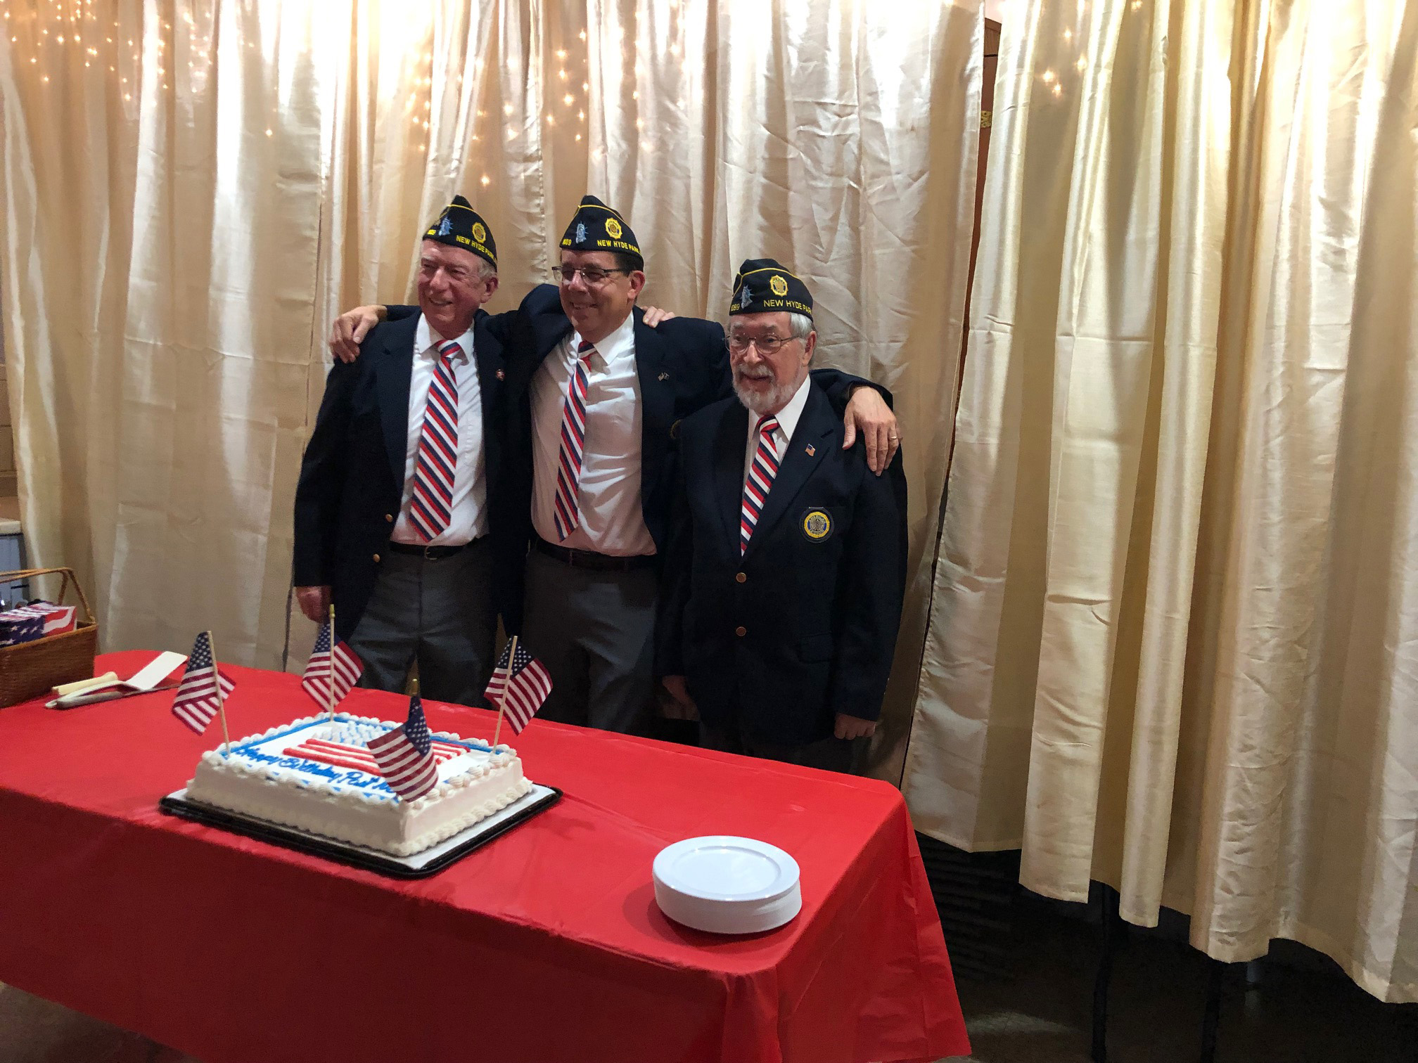
- Our Post’s 2022 Birthday Dinner was held at Saint Anne’s K of C Hall, Glen Oaks, New York. Holding the Dinner at this location has saved our Post a great deal of money. Everyone who attended had a great time. A special thanks must go to Ray and Marianne Minicus, Robert and Maureen Contegni and Rob and Sheila Nordman for making the Dinner possible. They formed a Dinner Committee that did everything from making all the arrangements up to and including hosting the Dinner. A lot of work. Thanks to all.

- Sadly we lost a 35 year member of our Post, Chris Constant. Our Honor Guard was able to conduct a wake service for our fallen brother. The family was very grateful for the service.

Our next meeting will be on Saturday March 18th 2023, at 10:00 AM in Village Hall on Jericho Turnpike. Please join us at this meeting if you can. If we have enough members at the meeting we will have pizza and soda after the meeting.
Left to Right – “Treasurer - Raymound Minicus”, “Adjutant - Rainer Burger”, “Vice Commander - John McGuire” (2022 Post Birthday Dinner)

If you have any questions do not hesitate to call me or one of our officers.

Local Post Officer Contacts: Meeting Dates: 2023
Commander - Bill Hothan - (516- 884-8179) March 18, 2023 (rescheduled from March 11)
Adjutant - Rainer Burger - (516- 510-5897) April 8, 2023
Vice Commander- John McGuire - (516- 640-2468) May 13, 2023
Treasurer - Raymond Minicus - (516- 459-6885) June 10, 2023

Remember: Membership is the life blood of any organization. If you do not pay your dues we have no choice but to drop you from our roster. With the continued loss of membership, we may soon not be able to continue our participation in Community activities such as Parades, and Street Fairs. This would be a great loss not only to the New Hyde Park Community but also to the veterans we support. Please try to find time to help us out.
Remember: the passing of the “Legion Act” moves the wartime era date back to Dec. 7, 1941. This makes our “Cold War” veterans eligible for membership. If they have served Federal Active Duty in the United States Armed Forces since December 7, 1941, and have been honorably discharged or are still serving - they may now be eligible for membership in The American Legion.
Remember: you are a member of the AMERICAN LEGION the largest veteran’s organization in America.
You have EARNED the right to be a LEGIONNAIRE; it is something to be very proud of.

For God and Country John J. McGuire
Vice Commander

