Nassau County American Legion
Department of New York

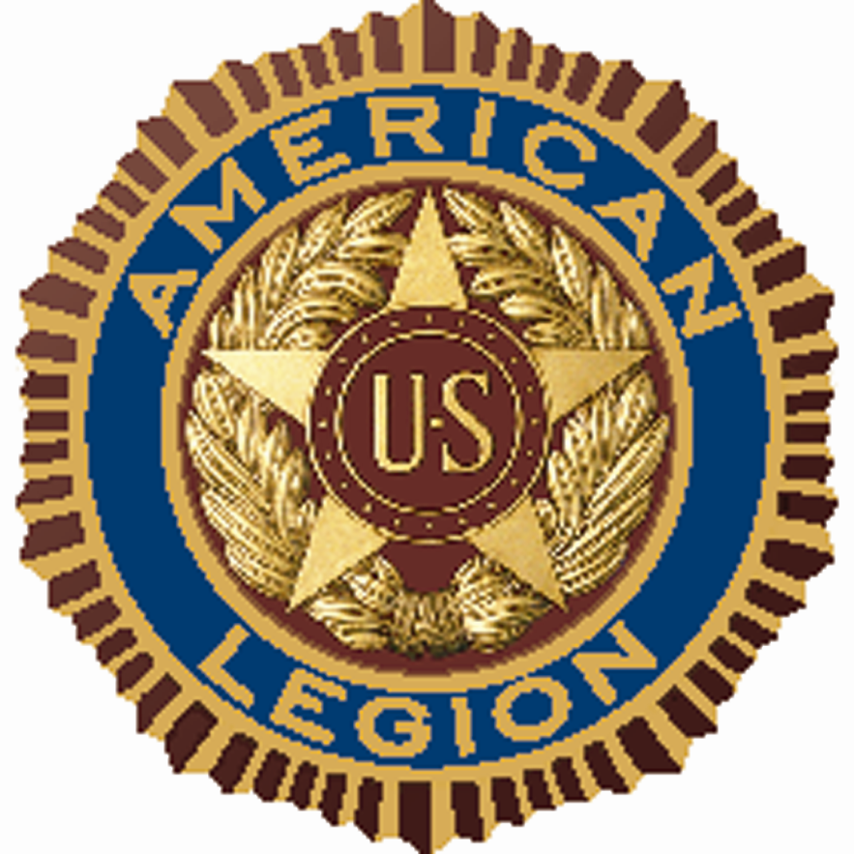

Nassau County September 26, 2025 Meeting

(Only Post Representatives, Alternate Representatives, Post Commanders, and Past County Commanders may answer roll call and vote. Fifteen members entitled to vote shall constitute a quorum, Constitution and Bylaws’ Article VII, Section 2.)

Meeting start 2000 hours
- PLEDGE OF ALLEGIANCE.
- County Chaplain Spinner rendered the invocation
POW/MIA EMPTY CHAIR CEREMONY
- SERGEANT-AT-ARMS placed the POW/MIA flag on the empty chair
- Sergeant @ Arms Led Reciting THE PLEDGE OF ALLEGIANCE

- THE PREAMBLE OF THE CONSTITUTION OF THE AMERICAN LEGION
- Adjutant read roll call of the elected staff, post representatives, and Past County Commanders
5 County Staff members and 4 appointed (see attach 2a)
20 Posts (see attach 2b-2f)
9 Past County Commanders (see attach 2g)
- Sign in sheets – (see attach 1 a–c)
- A motion to accept the minutes from the previous meeting of August 22, 2025 made by Chaplain Spinner and seconded by Robert Guarneri. Motion carried
Commander Samuel recognized Legionnaires who were in attendance for the first time
COMMITTEE AND OFFICERS REPORTS
ADVISORY- PCC Stephen McManus No problems
AMERICANISM- PCC Al Ficalora (attach 3a)
BOYS STATE – William Laderer, nothing to report

CHILDREN & YOUTH – Frank Neal, no report

LEGION CRUISERS – a new committee is being formed similar to the Legion Riders. There are currently two groups that have begun with the Massapequa Post. Jeff from Post 1066 was introduced and he will be the committee chairman
DIRECTORY- Eric Spinner – we are lacking input from many posts

EDUCATION – No report
FINANCE – On behalf of Treasurer Paternostro, Robert Guarneri presented a motion to accept the current treasurer’s report. It was accepted by PCC Scarola and 2nd by William Marinaccio. See report at 3b. Robert also reported that the Nassau Fund participation is lower than anticipated

HISTORIAN & AWARDS – James Randle – he is asking if anyone is interested in becoming the County Historian, please contact him. See report 3c

COMFORT WARRIORS – PCC Neal is requesting any donations and made it a point to say that all funds collected are spent on veterans in Nassau County. See report at 3d

CREDENTIALS AND CHARTERS – PCC Joseph Scarola; no report

LAW & ORDER- Committee Chair Kevin Tirman - Submission forms for the posts are located in the back of the room. They are the same with exception to the date. In order for your posts’ nominee(s) to be considered for a County award, the Law and Order Committee must be invited to your award presentation. PCC Scarola announced that Rockville Centre will have their Law & Order on Friday, Oct 10th at 1930 hrs

LEGION RIDERS - There are now currently three Rider group; Elmont, Massapequa and East Meadow. See monthly report at attach 3e

LEGISLATIVE BREAKFAST – Adjutant Pirozzi advised that all invitations have been mailed to the County Posts, County Commanders, District Commander and elected officials. The incoming response has been very slow. He met with Joe Clark of Post 1066 to go over the menu and the number of people expected

MEMBERSHIP – Greg Faling – The following Nassau County Posts have been selected to have their Post Charters terminated by both Department of New York and National HQ American Legion due to being non-functional:
Nassau Police Post #1050; Robert Van Cott #1861; Gomillion-Campbell #1488. If a post is finding that they are no longer able to function, it is important to consider getting the remaining members to transfer to a post of their choice rather than being placed into Post 1 which doesn’t benefit Nassau County. Also, when there is a change of officers within a post, please complete the Officers Certification Form (OCF – available on the Department website) and submit to Greg. If your post incorrectly reported the dues to Department, you must contact Greg within 30 days in order to get the change made for the next round of dues reminders that will go out to the membership soon. PUFL payments are currently due. Please send a check made payable to Nassau County American Legion, to Treasurer Paternostro at 4011 Bernice Rd, Seaford, NY 11783. Please note your post # and number of PUFL’s. A reminder; the Department District Commander will be presenting a membership seminar on Oct 4th and also show you how to get on line with My Legion.
MEMORIAL LIBRARY- Bill Marinaccio- no report

ORATORICAL – Jr PC Kerry Englander – letters have gone out announcing the upcoming contest. Kerry will be meeting with Hofstra University to confirm the date and time. It has been scheduled for Dec 13th at 10am. A breakfast will be available. See attach 3f

LONG ISLAND VETERANS HOME – DC John Hassett – no report

VETERANS SERVICES- Mary Norris & Tom Basacchi- The veterans at Bldg 92 were very excited to see the Day at the Races resume. If a post cannot participate, they are requested to give a $50 donation so that items can be purchased for the residents. See attach 3p. Chaplain Spinner mentioned that the full calendar for Day at the Races is posted on our website. Mary also spoke about ALIVE. A new committee was formed at the Mid Winter conference and Department has set up an office for this committee. See attach 3o

SCOUTING - Rainer Burger - If your post is chartered with a troop, applications for a scholarship for Eagle Scouts are available. If you do not have a troop and an Eagle Scout has a family member who is a Legionnaire, that person can also apply. Madame Commander also added that this year there will be awards for Troop of the Year, Scouter of the Year, Cub Scouter of the Year and new for this year, Girl Scout of the Year. see attach 3h

SPECIAL WELFARE – Past Department Vice Commander Harry Ransom – County is authorized to provide monetary assistance in a partnership with a Post for a member who is experiencing financial need. The post must submit documentation to County and if approved, we will match the funds donated by the Post up to $500. A letter from the post must be sent to PDVC Harry Ransom at #1 3rd Ave, Apt 922, Mineola, NY. 11501

SERVICE OFFICER/VETERANS ADVISORY – Edward Aulman – see attach 3i

HOMELAND SECURITY, POW-MIA & NATIONAL DEFENSE
Bob Hare – see attach 3j & 3 k
OFFICERS REPORTS
TREASURER- (attach 3b)

VICE COMMANDERS
1ST DIVISION Vice Commander David Vanderwerf- (attach 3l)
2ND DIVISION Vice Commander Mike Capillo- (attach 3m)
3RD DIVISION Vice Commander Mary Norris- (attach 3n)

COMMANDER’S REPORT – Commander Samuel mentioned that if any post would like to start an SAL squadron, contact her. Also, the Commander and Phoebe Ervin attended the Manhasset American Legion Auxiliary 50th Anniversary. In attendance was the American Legion, Sons of the Legion and Boys Scouts. The Junior Members of the Auxiliary set the POW table. see attach 3q
UNFINISHED BUSINESS - None
CORRESPONDENCE- None
NEW BUSINESS - PCC Robert Guarneri reported that there will be a Veterans Day Ceremony on Sunday, Nov 9th at Eisenhower Park at 1000 hrs followed by a ceremony at the Long Island National Cemetery at 1330 hrs. Your attendance is requested. Also, the yearly Standown will take place at the Freeport Armory on Nov 25th at 0900 hrs. Mid-Winter conference is scheduled for January 16-18, 2026 and the Department Convention will be held July 14 – 18, 2026
GOOD OF THE LEGION - Jr Past Commander Englander spoke about his experience at the National Convention in Tampa and has provided us information about the many awards that were presented. In particular, our Oratorical candidate did well and did come away with a monetary prize for her performance. Kerry said that many people were impressed by Katherine and she will be back again to compete in this new Legion Year. See attach 3r

CORRESPONDENCE – None

-Next month’s meeting PLEASE NOTE WE WILL BE MEETING AT THE ROCKVILLE CENTRE POST, Oct 24, 2025
-Thank you, Post Commander Ronnie West for the use of the post for our meeting
Motion to adjourn made by PCC Al Ficalora and 2nd by PCC Joseph Scarola. (2125 hours)
County Chaplain Eric Spinner ended with a closing prayer

SERGEANT-AT-ARMS recovered the POW/MIA FLAG
Closing statement followed by the hand salute to our Country’s Flag
Meeting Adjourned

