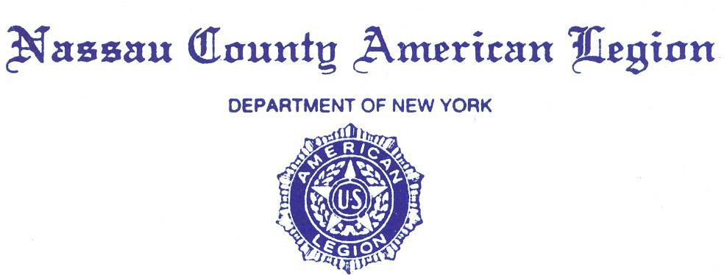

**MINUTES**

**Friday, November 22, 2024**

Commander Kerry Englander opened the General Meeting at 8 PM.

Opening prayer was given by County Chaplain Pat Alesia, followed by:

* The POW/MIA ceremony,
* The Pledge of Allegiance,
* The Preamble of the Constitution of the American Legion.

Adjutant Dawn Samuel conducted Roll Call. In attendance were 20 Legionnaires.

* 7 County Staff Members,
* 17 Posts,
* 8 Past County Commanders:

Harry Ransom PDVC, John Hassett, Steve McManus, Frank Neal, Robert Guarneri, Al Ficalora, Pat Alesia, Joseph Scarola.

* Adjutant Dawn Samuel informed County Commander Kerry Englander that there is a Quorum. **See Attach Roll Call #1a, b, c and 2a, b, c, d, e, f, g, h.**
* requested a motion to accept the Minutes of Oct. 24, 2024. Motion to accept the Minutes of Oct. 24, 2024, was made Kevin Tirman. Motion seconded by PCC Pat Alesia. Motion carried by Voice Floor Vote.

**Committee Reports**:

1. Advisory - PCC Pat Alesia: No Report.
2. Americanism – PCC Al Ficalora: Doug Collins nominee to head VA- looking up toward VA support. See report for full details **See Attach # 3**a and 3b.
3. Children and Youth – PC Frank Neil: Upcoming in December- Waterfront Warriors in Long Beach **See Attach # 4**
4. Operation **C**omfort **W**arriors – PCC Frank Neal: Contributions for the month of November 2024 were $400. Total contributions to date are $1,799. **See Attach # 5**
5. Oratorical- 9 students will participate- see report for full details **Attach # 6**
6. National Emergency Fund- PCC Pat Alesia- $1775 representing 35.5% of the goal. See report for full details **Attach # 7**
7. Convention Awards and Trophies – James Randle: No Report.
8. County Legionnaire 2025 – details to come in January- PCC Pat Alesia:
9. Credentials and Charters – PCC Joe Scarola: no report
10. Directory –Eric Spinner: “on the printer”
11. National Legacy Scholarship PCC John Hassett See **Attach # 18**
12. Employment Public Relations Veterans Advisory Nassau County – Ed Aulman: No Report.
13. Finance Committee – PCC Bob Guarneri: Motion to accept Finance report and motion to second- voted on the floor
14. Nassau Fund Raffle – PCC Bob Guarneri: $3000 collected so far gave out $700
15. Historian – James Randle: - No Report.
16. Homeland & National Security, POW/MIA – Robert Hare: see **Attach # 8a-f**
17. Law & Order – Kevin Tierman: See **Attach #9**
18. Legislative Breakfast – PCC Joseph Scarola: Message-“Importance of RSVP-ing on a timely basis” See **Attach # 10a & 10b**
19. Legion Riders – Kevin Tierman: **See Attach # 11**
20. LINCMO – PCC Pat Alesia: See **Attach #7**
21. Membership – Greg Faling, please send the names when you are sending the per capita to the county
22. Military Ball/Post Commanders Night – PCC Joe Scarola Past Dist. Cdr Frank Colon Jr, annual Military ball / Post Commanders Night will be at Leonard’s Palazzo, 555 Northern Boulevard, Great Neck, New York, 11021, from **11:30 Am** to 5:00 PM on Sat Feb 15, 2025.
23. National Commander’s Dinner – PCC A Paternostro and County Cdr Kerry Englander: April 12, 2025. No Report.
24. National Emergency Fund (NEF) – PCC Pat Alesia: Our County Goal for the Legion Year 2023–2024 will be $6,000. Total donations thus far as of this NCAL meeting is $2,910. This is 48.5% of our goal. Thank you to all that have donated. 1. Merric Post 1282, 2. Nassau police Post 3. New Hyde Park Ernie Pyle Post 1089 4, East Rockaway Post 858 5. Kerry & Elizabeth Englander. See **Attach # 7**
25. POW/MIA – Bob Hare: See **Attach # 8a-f**
26. Scouting – Reiner Burger. Scouts working to help Veterans= see full report **Attach #12**
27. Service Officers – Ed Aulman, Ralph Esposito for employment opportunities- (516)572-6565 **See Attach # 13**.
28. Sons of the Legion – PCC John Hassett: no report
29. Veterans Advisory Committee (VAVS) – PCC Pat Alesia, PCC Al Ficalora, and PCC Joseph Scarola**: See Attach #7 \*\***Flag presented to Commander Kerry Englander from the office of Congressman Tom Suozzi (YAY)
30. Webmaster – Chaplin Eric Spinner: no report.

* 1st DIVISION Report – Al Ficalora. **See Attach # 14.**
* 2ND DIVISION Report – VC Arthur Pirozzi: **See Attach # 15.**
* ADJUTANT Report – Dawn Samuel:
* Please bring written reports to the meetings as well as emailing them to [tigger514@outlook.com](mailto:tigger514@outlook.com)

**CORRESPONDENCE**

* Check out the flyers that are on the table. See “flyers” attachment
* CHAPLAIN REPORT – Eric Spinner: see attachment for tonight’s prayers **Attach #16**

**UNFINISHED / OLD BUSINESS** –

* None.

**NEW BUSINESS**

* None.

**GOOD OF THE LEGION**

* COMMANDER’S REPORT – See attachment #17 for Commanders Report.

**MOTION TO ADJOURN.**

Closing prayer was given by PCC Pat Alesia.

For God and Country

Respectfully submitted,

Dawn Samuel

Dawn Samuel

Adjutant

Nassau County American Legion