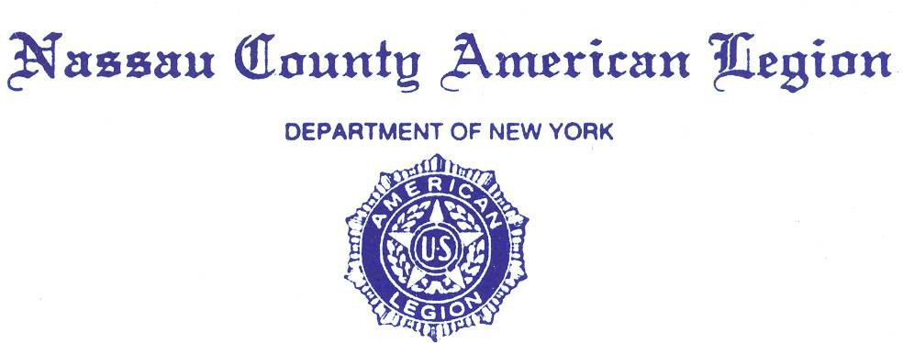

**MINUTES**

**Friday, December 27, 2024**

Commander Kerry Englander opened the General Meeting at 8 PM.

Opening prayer was given by County Chaplain Eric Spinner, followed by:

* The POW/MIA ceremony,
* The Pledge of Allegiance,
* The Preamble of the Constitution of the American Legion.

Adjutant Dawn Samuel conducted Roll Call. In attendance were 26 Legionnaires.

* 9 County Staff Members,
* 17 Posts,
* 8 Past County Commanders:

Anthony Paternostro, Angelo Grande, John Hassett, Steve McManus, Frank Neal, Al Ficalora, Pat Alesia, Joseph Scarola

* Adjutant Dawn Samuel informed County Commander Kerry Englander that there is a Quorum. **See Attach Roll Call #1a, b, c and 2a, b, c, d, e, f, g, h.**
* requested a motion to accept the Minutes of Nov. 22, 2024. Motion to accept the Minutes of Nov. 22, 2024, was made. Motion seconded. Motion carried by Voice Floor Vote.

**Committee Reports**:

1. Advisory - PCC Anthony Paternostro: No Report.
2. Americanism – PCC Al Ficalora: “This is a great opportunity to celebrate a man… took selfless actions … to help his fellow man…” read more- **See Attach # 3**
3. Children and Youth – PCC Frank Neil: December parties and Santa sightings- For full report **See Attach # 4**
4. Operation **C**omfort **W**arriors – PCC Frank Neal- no report
5. Oratorical- Two Nassau County winners!! Katherine Mazaroski- first place and Abigail Hassett 2nd place= Please come and support them at District Competition on January 11 Jan 2025, 9-11am Levittown Post. Many thanks to all those that helped to make this year a success- see report for full details. **Attach # 5**
6. National Emergency Fund- PCC Pat Alesia- $2700 representing 54% of the goal. See report for full details **Attach #6**
7. Convention Awards and Trophies – James Randle: Going to mid-winter to get the information to pass onto post commanders.
8. Legionnaire of the Year 2025 – details to come in January- PCC Pat Alesia:
9. Credentials and Charters – PCC Joe Scarola: no report
10. Directory –Eric Spinner- still reaching out for information, getting a QR code set up for “authorized” people to have access to information
11. National Legacy Scholarship PCC John Hassett- no report
12. Employment Public Relations Veterans Advisory Nassau County – Ed Aulman: No Report.
13. Finance Committee – PCC Anthony Paternostro: Motion to accept Finance report and motion to second- voted on the floor *noted in the report that per capita still needed to be paid See **attach 14a-e**
14. Nassau Fund Raffle – PCC Bob Guarneri: no report
15. Historian – James Randle: - No Report. Will be attending mid-winter to receive updated information
16. Homeland & National Security, POW/MIA – Robert Hare: Gang infiltrating from prisons in Venezuela into the united States…, New Orleans Border Patrol seizing $150,000 from Latin Kings gang … Read more of these Homeland Security details see **Attach # 7a-e** and POW/MIA report in reference to Medal of Honor recipient Lt Col Addison Baker’s final honors at Arlington National Cemetery **attach #8 a-c**
17. Law & Order – Kevin Tierman: Full details recent Law & Order ceremonies and upcoming ceremonies See **Attach #9**
18. Legislative Breakfast – PCC Joseph Scarola no report
19. Legion Riders – Kevin Tierman: **See Attach # 10**
20. LINCMO – PCC Pat Alesia: no report
21. Membership – Greg Faling- see attach #11
22. Military Ball/Post Commanders Night – PCC Joe Scarola Past Dist. Cdr Frank Colon Jr, annual Military ball / Post Commanders Night will be at Leonard’s Palazzo, 555 Northern Boulevard, Great Neck, New York, 11021, $80pp from **11:30 Am** to 5:00 PM on Sat Feb 15, 2025. See attach **#12 a,b**
23. National Commander’s Dinner – PCC A Paternostro and County Cdr Kerry Englander: April 11, 2025. No Report.
24. Scouting – Reiner Burger. Eagle court of Honor, 28 Dec 2024, all encouraged to attend and support our future. For full report **Attach #13**
25. Service Officers – Ed Aulman, Ralph Esposito for employment opportunities- (516)572-6565
26. Sons of the Legion – PCC John Hassett: no report
27. Veterans Advisory Committee (VAVS) – PCC Pat Alesia, PCC Al Ficalora, and PCC Joseph Scarola- East Northport Medical Facility new phone system **: See Attach #6**
28. Webmaster – Chaplin Eric Spinner: no report.

* 1st DIVISION Report – Al Ficalora. **See Attach # 15.**
* 2ND DIVISION Report – VC Arthur Pirozzi: **See Attach # 16.**
* **3**rd DIVISION Report- Ralph Case**y- See attach # 17**
* ADJUTANT Report – Dawn Samuel:
* Please bring written reports to the meetings as well as emailing them to [tigger514@outlook.com](mailto:tigger514@outlook.com)

**CORRESPONDENCE**

* No correspondence
* CHAPLAIN REPORT – Eric Spinner: 4 Chaplain’s Ceremony- United Methodist Church, Hempstead, 2 Feb 2025

**UNFINISHED / OLD BUSINESS** –

* None.

**NEW BUSINESS**

* None.

**GOOD OF THE LEGION**

Anyone planning to run for a county officer position, please have a letter from your post commander send out to all the posts and Past County Commanders after mid-winter. The position of County Commander is to be sent out the Friday before mid-winter

* COMMANDER’S REPORT – See **attachment #18** for Commanders Report.

**MOTION TO ADJOURN Meeting Adjourn 8:57 pm**

Closing prayer was given by Eric Spinner.

For God and Country

Respectfully submitted,

Dawn Samuel

Dawn Samuel

Adjutant

Nassau County American Legion