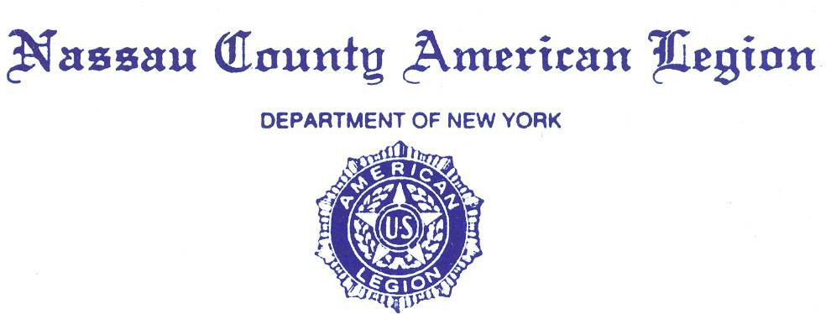

**MINUTES**

**Friday, Aug 18, 2023**

Commander Sean Hood opened the General Meeting at 2000 hours.

Opening prayer was given by County Chaplain Eric Spinner. followed by:

* The POW/MIA ceremony,
* The Pledge of Allegiance,
* The Preamble of the Constitution of the American Legion.

Adjutant Kerry Englander conducted Roll Call. In attendance were: 32 Legionnaires.

* 6 County Staff Members
* 18 Posts
* 8 Past County Commanders:

Joseph Scarola, Frank Neal, Pat Alesia, Robert Guarneri, Tony Paternostro,

Al Ficalora, John Hassett, Frank Colon Jr. (Past Dist. Cdr.).

* Adjutant Kerry Englander informed County Commander Sean Hood that there is a Quorum. **See Attachments #1a, b, c and 2a, b, c, d, e, f, g, h.**
* Adjutant Kerry Englander requested a motion to accept the minutes.

of July 28th, 2023. 1st Motion to accept the minutes of July 28th, 2023, was PCC.

Al Ficalora Motion carried by Voice from the floor and accepted by Commander Sean Hood.

**Committee Reports**:

1. Advisory
2. Department Visitation Dinner $75 per person at the Coral House in Baldwin

**See attach #3**

1. Americanism - PCC Andrew Booth: No report
2. American Legion Monument Fund – Past Dist. Cdr. Frank Colon Jr.: No Report
3. Boys State – Bill Laderer: 42 Delegates attended Boys State this year.
4. Children and Youth – Dawn Samuels: **For details See Attach #4a, b.**
5. Operation Comfort Warriors – PCC Frank Neal: Is a program run by the AL and dedicated to meeting the needs of our wounded, ill, or injured. This fund is for Veterans mainly living here on Long Island.  **For details** **See Attach #5.**
6. Constitution and Bylaws – PCC John Hassett: No report.
7. National Legacy Scholarship Fund Protocol – No report
8. Convention Awards and Trophies – PCC Pat Alesia: No Report.
9. County Flyer – Past County Commander Pat Alesia & Past Dist. Commander Ken Cadieux: No Report.
10. County Legionnaire- – Pat Alesia: No Report.
11. Credentials and Charters – Past County Cdr Steve McManus & Past Dist. Cdr Ken Cadieux: No Report.
12. Department Commander Family Visitation – 10th District Past County Cmdr. Frank Colon, & PCC Anthony Paternostro: Visitation will start with breakfast. We then will escort all Family Visitation to the Cradle of Aviation and the unveiling of the F14. Our Dept Visitors will proceed to the Fire Museum followed by a visit to Veteran’s Memorial Park in Eisenhower Park. The Visit will end with a dinner @ the Coral House in Baldwin @ 6:30 PM.
13. Directory – PCC Anthony Paternostro: White Post directory sheets have been Emailed multiple times with a due date of August 1, 2023. Anthony stated please get them in so Anthony can build 2023/2024 Nassau County Directory. **For details** **See Attach #6**
14. Education & Scholarship – Chaplain E Spinner: No Report.
15. Employment Public Relations Veterans Advisory Nassau County – Ed Aulman: In Ed’s reporting he spoke about Lung cancer is the deadliest cancer among Veterans, Veterans and active-duty service personnel can save up to 20% with Avis or Budget rental cars until September 30, 2023.

Red Cross is low on blood donations, treatment of a rare form of ALS (Lou Gehrig’s disease), If you disagree with your VA decision on your claim filing a Supplemental Claim may be an option for you, The Yellow Ribbon Program can help you pay for higher out-of-state, private school.

**For details** **See Attach #7**

1. Family/Troop Support – Past Dist. Commander Ken Cadieux: No Report.
2. Finance Committee – PCC Bob Guarneri: Independent Auditors Report

**See Attach # 8 – 5 pages**

1. Nassau Fund Raffle – PCC R Guarneri: All Posts have received Raffle Tickets.
2. Historian – James Randle: - Yearbook given to Jr. Past County Cdr Joseph Scarola.
3. Homeland & National Security – Robert Hare: Prison sentence for Pascale Ferrier age 55 for sending threating letters to the 45th pres. Of the US, Former special agent pleats guilty to conspiring to Violate US Sanctions on Russia, Maritime Piracy showing signs of resurgence, FEMA should improve the Transit Security Grant program, Military recruiting crisis is getting worse, $362 million Decommissioned Naval ship in service less than 5 yrs..

**For details to all the above see Attach #9 - 4 pages**

1. Insurance Committee – PCC Anthony Paternostro: No Report.
2. Law & Order – Tom Basacchi: No Report
3. Legacy Scholarship Fund – PCC J Hassett: No Report.
4. Legislative Breakfast – Jr. PCC Joseph Scarola: Oct 7th at Massapequa Post 1066. **For details** **See attach #10**
5. Legion Riders – Kevin Tierman: **For details** **See attach #11. Elmont Riders Report July 2023**
6. Legionnaire of the year PCC Pat Alesia: No Report
7. LINCMO – Past Dist. Commander Ken Cadieux: No Report
8. Membership – Greg Faling: Discussed membership, All post have received their membership cards, Honorary Memberships paid by Posts PUFL Letters will be going out. **For details** **See Attach #12**
9. James N McLean Memorial Library – Past Dist. Cdr Ken Cadieux, William Marinaccio: No Report.
10. Military Ball/Post Commanders Night – Past Dist. Cdr Frank Colon Jr, Past County Commander Anthony Paternostro: Ball will be held on February 17, 2024, at Leonard’s of Great Neck.
11. National Commander’s Dinner – PCC A Paternostro/County Cdr Sean Hood: April 12, 2024. No Report
12. National Cemetery – PDC Ken Cadieux, PCC Pat Alesia: No Report.
13. National Emergency Fund (NEF) – PCC P Alesia: No Report.
14. Protocol – PCC John Hassett: No Report.
15. POW/MIA – PCC F Neal: No Report.
16. Resolutions – Past Dist. Cdr Ken Cadieux, County Cdr Sean Hood: No Report.
17. Rehabilitation – Tom Basacchi - Mary Norris briefly spoke about returning to Northport. Mary attended a Barbecue on Saturday Aug 12th. Ealy discussion regarding the return to Bldg. 92 and going to day of the races sometime between September 2023 and May 2024.
18. Scouting – Nassau County Scouting Champ came from 2nd Division New Hyde Park Ernie Pyle Post and reported by Adjutant Ryner Burger.
19. Service Officers – Ralph Esposito, Ed Aulman
20. Sons of the Legion – PCC J Hassett: No Report.
21. Special Welfare – PDVC H. Ransom: No Report.
22. United Veterans Organization (**UVO**) – PCC Andy Booth: No Report.
23. Long Island Veterans Home Advisory Board Stony Brook Hospital – Past Dist. Cdr Frank Colon Jr: No Report.
24. Veterans Advisory Committee – PCC Pat Alesia & PCC Al Ficalora: No Report.
25. Veteran Services – PCC Pat Alesia: See VA Committee report above.
26. Veteran Supplies – Past Dist. Commander Ken Cadieux: No Report.

**Officers Reports**

* 1st Division Report – VC Dawn Samuel **For details** **See Attach #13**: reported 2 Honorees from Nassau County AL John Hassett & Eric Spinner
* 2nd Division Report – VC Arthur Pirozzi: Veterans Services will be giving a presentation on August 19. **For details** **See Attach #14a, 14b, 14c.**
* 3rd Division Report – VC Ralph Casey: Glenwood Landing Meet Feedback was Negative as reported by Newsday
* Adjutant Report – Kerry Englander:
* Please bring written reports to the meetings as well as emailing them to: **summitax@optonline.net.**
* White sheets are on the table, please fill them and send them to Anthony Paternostro.

**Correspondence**

* Calander of Events

1. Wounded Warriors End of Summer Bash

At Geis park in Lynbrook, all proceeds benefit Veterans. Come one, come all. Support this annual fund raiser sponsored by the Lynbrook Fire Department. \

**For details see** **Attach # 15 – Wounded Warriors End of Summer leaflet.**

1. Veterans BBQ, Eisenhower Park Sept 14, 2023 - 11 AM – 6 PM.
2. POW/MIA Remembrance Ceremony, Sept 15, 2023, 7 – 9 PM
3. Walls of Honor Ceremony. Unveiling of new veterans’ names at Veterans’ Memorial Park @ Eisenhower Park Sept 30, 2023, 10 AM.
4. NY Assembly 21st District Run for Heroes – 5k to raise funds for Local VFWS and American Legions – All Proceeds go to Our Veterans Sept 9, 2023; See Attach

* The State of Veterans Service Organizations – Article by Christy Hinko Managing Editor of at Anton Media Group and US Navy Veteran. **See Attach 16 a, b.**
* Sgt at Arms/Color Guard – PCC S McManus: No Report.
* Chaplain Report – Eric Spinner: No Report.

**UNFINISHED / OLD BUSINESS** – Posts still awaiting $10,000 grants.

**NEW BUSINESS**

* Ed Aulman – Proposed to implement on the county level Robo-Call – discussions will continue as this would be an added cost to the county as the current communication process of Email & Texting is currently working. This topic was tabled for future discussion.

**GOOD OF THE LEGION**

* Commander John Noland volunteered Massapequa Post 1066 Amityville Pipe Band to enhance the Department Visitation.

1. Visitation at Coral House Dinner on Sept 14, 2023 - 6:30 PM

* Nassau County Oratorical – Adjutant Kerry Englander & PCC Anthony Paternostro met with Levittown Superintendent and the superintendent was quite impressed that these scholarship funds are available in addition to Boys State and the operation of it.

**For details** **See Attached #17 for 13 pages. This will be given to all candidates.**

* Retired LTC Jag (Lieutenant Col. Judge Advocate Corps (Lawyer)) Gary Port. Public relations officer and consultant. Acting Ambassador temporarily Major General is requesting from the American Legion some help with recruiting and other services. Gary Port spoke about how the Army is down 2 divisions due to the media focusing attention on the broken soldier. He spoke about the incentives going into the ROTC and commissioning into the reserves and the Guard and how once you have completed your time you will be given tuition free Education.
* **County Commanders Report**: The County Commander stressed Nassau County Joint Visitation of Dept Commander, SAL & Auxiliary President on Sept 14, 2023. Spoke briefly about negative Newsday article. Rebuttal followed.

**For details** **See Attach #17a, b.**

**Motion to Adjourn.**

A motion to adjourn was made by PCC Anthony Paternostro. Motion seconded by PCC Pat Alesia. Motion carried by Voice Floor vote.

The meeting was adjourned at **9:15 PM**.

Closing prayer was given by County Chaplain Eric Spinner.

Every day may not be good but there is always something good in every day!

For God and Country

Respectfully submitted,

Kerry Englander

Kerry Englander

Adjutant

Nassau County American Legion

God Bless The American Legion

God Bless America