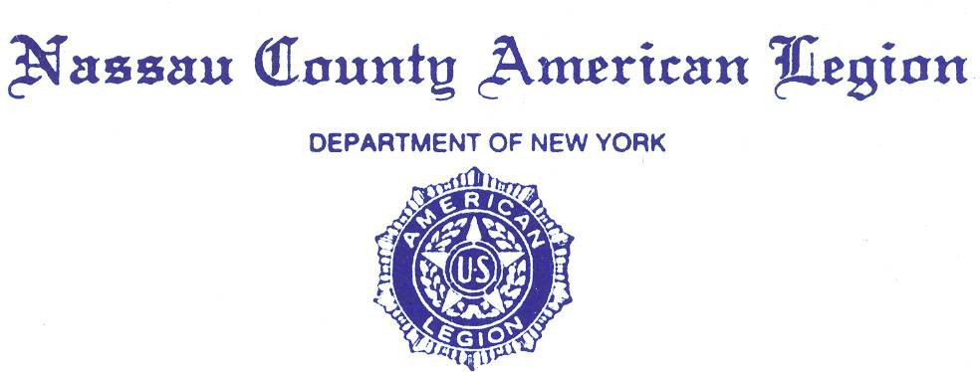

**MINUTES**

**Friday, 28 October 2022**

Commander Joseph Scarola opened the General Meeting at 2000 hours.

Opening prayer was given by Chaplain Eric Spinner, followed by:

* The POW/MIA ceremony,
* The Pledge of the Allegiance,
* The Preamble of the Constitution of the American Legion.

Adjutant Sean Hood conducted the Roll Call. Present were: 27 Legionnaires.

* 8 County Staff Members,
* 17 Posts,
* 10 Past County Commanders:

Pat Alesia, Dist. Commander Frank Colon, Jr., Al Ficalora, Robert Guarneri, Anthony Paternostro, Steven McManus, Angelo Grande, John Hassett, Frank Neal

Adjutant Sean Hood informed the County Commander that there is a quorum.

Dist. Commander Frank Colon, Jr. was recognized.

COMMITTEE Reports:

1. Advisory: PCC A Paternostro: He began with discussing the Nassau County Military Ball which will be held on 18 February 2023. The price is $75 per person. Letters will be going out as well as emails.

He then spoke about how Funerals and wakes are handled in the American Legion. We as an organization support ALL Veterans no matter if they are members or not. Posts are advised to use the chain of command. Post to County to Department. All effort must be made to accommodate a family of a Veteran to the best of the ability of the Post. We will not turn any Veteran away.

See Attachment #1

2. Americanism - PCC Andrew Booth: No report

3. American Legion Monument Fund – Dist. Cmdr. Frank Colon Jr.: No Report

4. Boys State – Bill Laderer: No Report

5. Children and Youth and Oratorical – Dawn Samuel:

a. There was a Trick or Treat party at the Marine Corps Base last week and it was a great success.

b. There will be a Christmas Party for the children. The date, time and place will be announced.

c. Susan Neville says that $5,000 worth of Clothing and Formula were donated

d. November 25 is the last date for Oratorical submissions

See Attachment #2

6. Operation Comfort Warriors – PCC Frank Neal: No Report.

7. Constitution and Bylaws – PCC John Hassett: No Report

8. National Legacy Scholarship Fund Protocol – PCC Anthony Paternostro: There will be a letter out this week detailing how we will pay for schooling of deceased warriors.

9. Convention Awards and Trophies – James Randle: No Report.

10. County Flyer – Past Dist. Commander Ken Cadieux: No Report.

11. County Legionnaire- – Past Dist. K Cadieux: No Report.

12. Credentials and Charters – Past Dist. County Commander Ken Cadieux: No Report.

13. Department Commander Family Visitation – Dist. Frank Colon, PCC A Paternostro: No Report

14. Directory – PCC Anthony Paternostro: No Report.

15. Distinguished Guests – 10th District Commander Frank Colon Jr.

16. Education & Scholarship – Chaplain E Spinner: No Report.

17. Service Officer – J. Paul Vista(Deputy Director), Ed Aulman: Ed gave out mini replicas of the US Constitution booklets. Northport Hospital is in very bad shape.

See Attachment #3

18. Employment Public Relations Veterans Advisory Nassau County – Ed Aulman:

No Report

19. Family/Troop Support – Past Dist. Ken Cadieux: No Report.

20. Finance Committee – PCC Robert Guarneri: Thanked members for their support for the Legislative Breakfast

See attachment #4 and #5

21. Nassau Fund Raffle – PCC R Guarneri: We are continuing to get money in. we are just short of our goal. Need 31 more tickets.

22. Historian – PC James Randle: No Report.

23. Homeland & National Security – Robert Hare:

See Attachment #6

24. Housing – Sean Hood: No Report.

25. Insurance Committee – PCC Anthony Paternostro: No Report.

26. Law & Order – Tom Basacchi: Post 303 Rockville Centre had a Law and order night and it was a great success.

27. Legacy Scholarship Fund – PCC J Hassett: No Report.

28. Legislative Breakfast – Dist. Chaplain A Booth:

See attachment #5

29. Legion Riders – Kevin Tierman:

See Attachment #8.

30. Legionnaire of the Year – PCC P Alesia. No Report.

31. LINCMO – Past Dist. Ken Cadieux: No Report.

32. Membership – PC Greg Faling: No Report

33. James N McLean Memorial Library – Past Dist. Commander Ken Cadieux. William Marinaccio:

See Attachment #9

34. Military Ball/Post Commanders Night – Dist. Commander Frank Colon Jr,

Past County Commander Anthony Paternostro:

See County Advisory Report Page 1 #1

35. Nassau Fund – PCC Robert Guarneri: R Guarneri again emphasized that the primary income to the Nassau County American Legion is from this voluntary fund raiser. We are 31 tickets short of our goal.

36. National Commander’s Dinner – PCC A Paternostro/PC J Scarola: No Report.

37. National Cemetery – PDC K Cadieux, PCC Pat Alesia: The new Director William Tavaras will have a meeting soon. Date and time TBD.

38. National Emergency Fund (NEF) – PCC P Alesia: We have a goal of $5,000. Numerous Posts in Nassau County have already contributed. We have received $1,425 to date.

39. Protocol – PCC John Hassett: No Report.

40. POW/MIA – PCC F Neal: No Report.

41. Public Relations and Veterans Advisory Committee Nassau County – Ed Aulman:

No Report.

42. Resolutions – Past Dist. C Ken Cadieux, Adjutant Sean Hood: No Report

43. Rehabilitation – Mary Norris & Tom Basacchi: The VA is in trouble Please bring food to the East Meadow Pantry.

44. Scouting – No Report

45. Sons of the Legion – PCC J Hassett: No Report.

46. Special Welfare – PDVC H. Ransom: No Report.

47. United Veterans Organization (**UVO**) – Andy Booth: No Report.

48. Long Island Veterans Home Advisory Board Stony Brook Hospital –

Dist. Commander Frank Colon Jr: No Report

49. Veterans Advisory Committee – R Esposito: No Report.

50. Veteran Services – PCC Pat Alesia: No Report.

51. Veteran Supplies – Past Dist. Commander Ken Cadieux: No Report.

Officers Reports

1st Division Report – VC Dawn Samuel: - See Attachment #10

2nd Division Report – VC Kerry Englander: See Attachment #11

3rd Division Report – VC Ralph Casey: Ralph discussed suicide by our Veterans and how we hope future Veterans from taking their lives.

1. Ralph also discussed the SAR Flag (Suicide Prevention Flag which was designed by Kevin Hartell who is an Air Force Veteran. On Nov 23, 11:00 – 12:30 PM at Glen Head American Legion. The SAR Flag was raised, the reason for this event is that 20 Veterans die every day & many could be saved with funding for Medical Needs.

Newsday will have a two-page spread for the event and will appear on CBS & WPIX. More than 20 politicians will attend; Legion Riders; Bands from nearby High Schools; as well as nearby Posts. It is estimated 1,000 - 2,000 people will be in attendance.

1. On September 29, 2022 Third Division had a crisis meeting with all third division commanders. The need for this meeting was to address the possible closing of posts.

Attended Nassau County Legislative Breakfast. Worked Oktoberfest benefit night at Glenwood landing.

See Attachment #12

Adjutant Report – Sean Hood: - Please bring written reports to the meetings. Also please email reports to me [Militaryman32874@aol.com](mailto:Militaryman32874@aol.com)

Treasurer – PCC Anthony Paternostro: See Attachment #4, #5

Sgt at Arms/Color Guard – PCC S McManus: No Report.

Chaplain Report – Eric Spinner: No Report.

Correspondence

See Attachment #14, #15.

UNFINISHED / OLD BUSINESS

NONE.

NEW BUSINESS

Nassau County Veterans Pantry needs food due to inflation affecting donations. Especially meat. The Pantry is very low on meat.

A motion was made by PCC Pat Alesia and seconded by PCC Robert Guarneri to approve $1,500 from comfort Warriors. We will do the shopping for the Veterans Pantry.

Motion Carried.

GOOD OF THE LEGION

a. East Meadow Post is assisting with a food drive at their post on Nov 5.

See Attachment #16

b. Baldwin Post #246 is having a Veterans Day ceremony on Friday Nov 11 at their Post

See Attachment #17

c. Queens County American Legion is having a Parade on Sunday November 13.

See Attachment #18

d. The 247th Marine Corps birthday Ball will take place at Terrace on the Park in Queens on 3 Nov 2022.

See Attachment #19

e. There was a food drive by AARP that has contributed to Veterans.

f. Center for Medicare Services is working with Tom Basacchi to lower costs for Veterans.

g. Chinese American Organization contributed a large sum of money to the LI State Hospital for Veterans in Stony Brook.

Introduction of Guests.

The Post Commander of Post 81 J Franklin Bell Post Gary Port attended the County meeting and spoke in length about numerous items affecting the military and Army in particular. He is a MG and an Army Reserve Ambassador.

The US Army is 22,000 recruits short of their goals. The Marines barely accomplished theirs and the other services are in trouble too.

COVID had kept recruiters out of High Schools and ABSFAB scores are very low because of COVID too. On top of that, Obesity is up, and recruits are having trouble completing goals. The Army is starting a Pre-Boot Camp to help get soldiers ready and able to pass.

The Mainstream Media is not helping by incorrectly calling all Veterans “broken” because of 20 years of war in the middle east. The Army has hired an Advertising firm to assist in recruiting.

MG Port asked all the members to act as ambassadors for the services to help recruiting.

He discussed ROTC opportunities and bonuses.

County Commanders Report

See Attachment #13

Motion to adjourn

A motion to adjourn was made by PCC J Hassett and seconded by Dist. Commander Frank Colon. Motion carried by Voice Floor vote. Meeting adjourned at 2108.

Closing prayer was given by Chaplain Eric Spinner.

Respectfully submitted,

For God and Country

Sean Hood

Adjutant

Nassau County American Legion

God Bless The American Legion

God Bless America