Nassau County American Legion
Department of New York
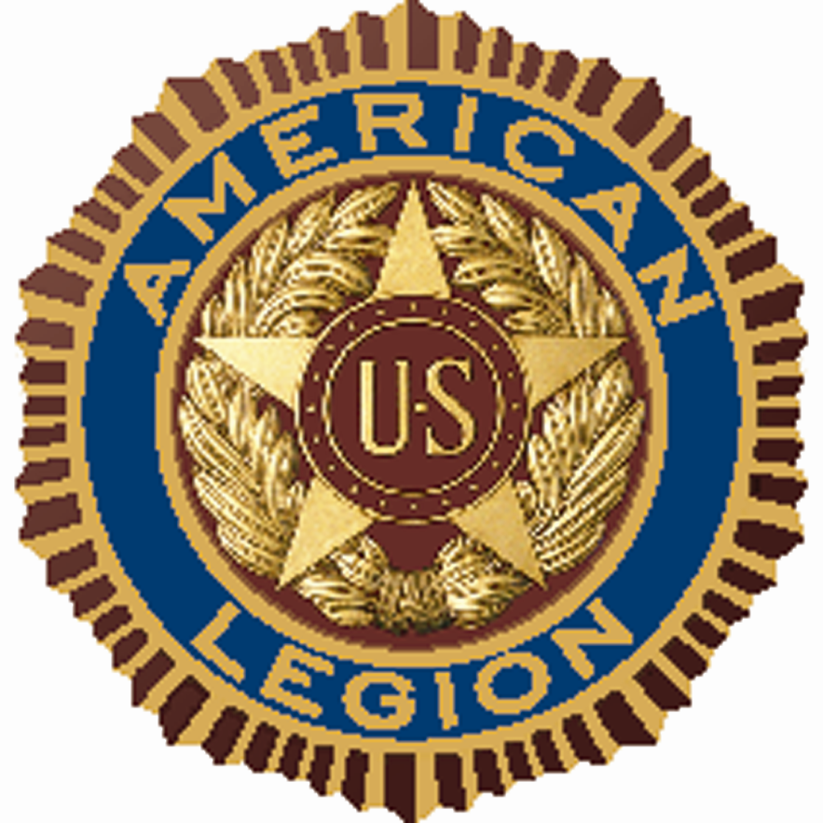

MEETING DATES: 2022 – 2023

Rockville Centre Post #303
197 Maple Avenue
Rockville Centre, NY 11570

Monthly Meetings:
Advisory 7:30 PM
County 8:00 PM

2022:
June 17 Staff Meeting
June 24 Organizational Meeting
July 22 Executive
August 19 Executive
September 23 General
October 28 Executive
November 18 Executive
December 23 General

2023:
January 27 Executive
February 24 Executive
March 24 General
April 28 Executive
May 26 Executive
June 3 Convention
June 4 Installation

